EXPERIMENT 5
AIM: To generate relational and multidimensional reports using Power BI and create comparative visualizations for business decision-making.
OBJECTIVES:
- Generate relational reports using transactional data.
- Create multidimensional reports using Geo_Hierarchy.
- Apply sorting, filtering, and drill operations.
- Develop comparative charts and interactive dashboards.
THEORY:
Power BI provides Table and Matrix visuals for relational and multidimensional reporting. Sorting, filtering, aggregation, and drill-down operations help analyze business data. Comparative charts and dashboards present meaningful insights for decision-making.
DATASET USED:
Global Superstore Dataset containing:
- Fact_Sales
- Dim_Customer
- Dim_Product
- Dim_Region
- Dim_Date
- Geo_Hierarchy (Region → State → City)
PROCEDURE:
- Open the Experiment 4 Power BI file and verify the star schema relationships. Create a copy of experiment 4 Power BI file and rename it to Experiment 5.

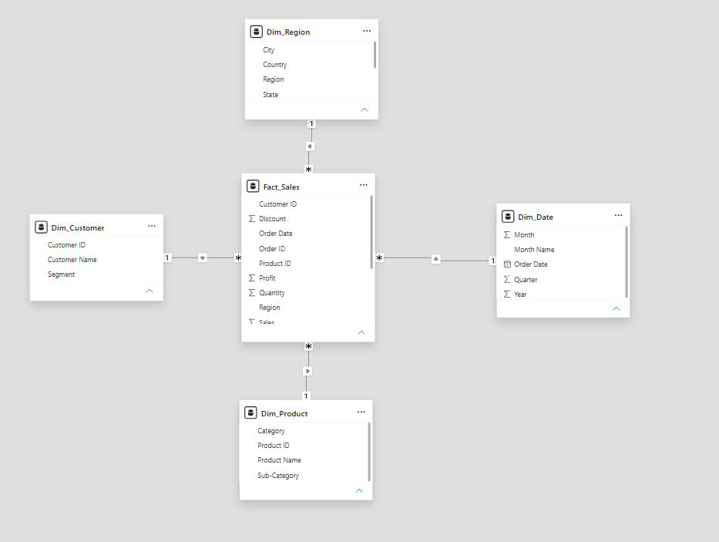
- Check the Geo_Hierarchy and previously created Slice, Dice, and Drill pages.

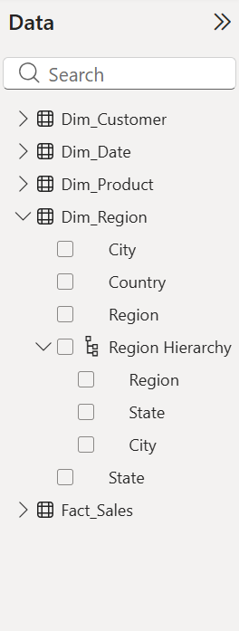
- Create a Relational Report page with a Table visual, add the required fields, sort Sales in descending order, apply Profit greater than zero filter, and export data.
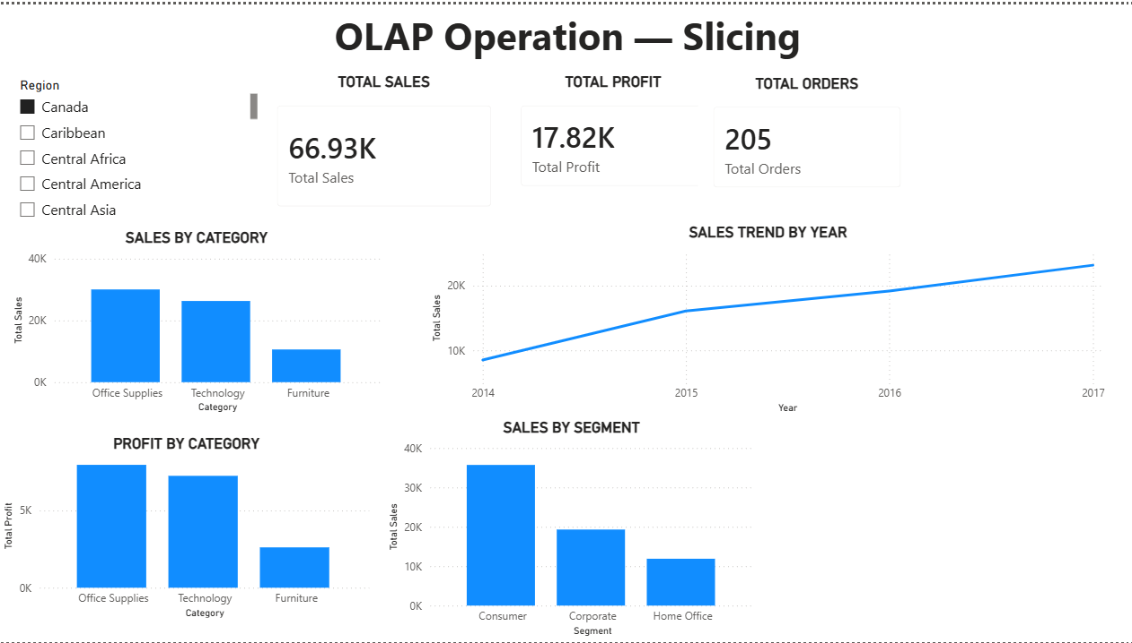

- Create a Matrix Report page, add Geo_Hierarchy to Rows and Total Sales, Total Profit, and Quantity to Values.
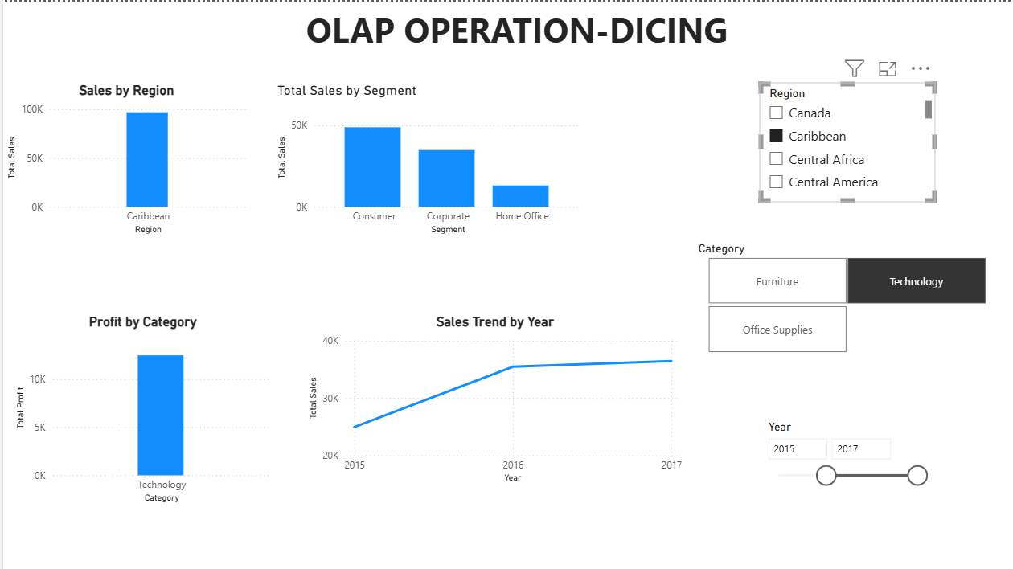

- Perform drill-down and drill-up operations from Region to State and City, and compare results with Experiment 4.
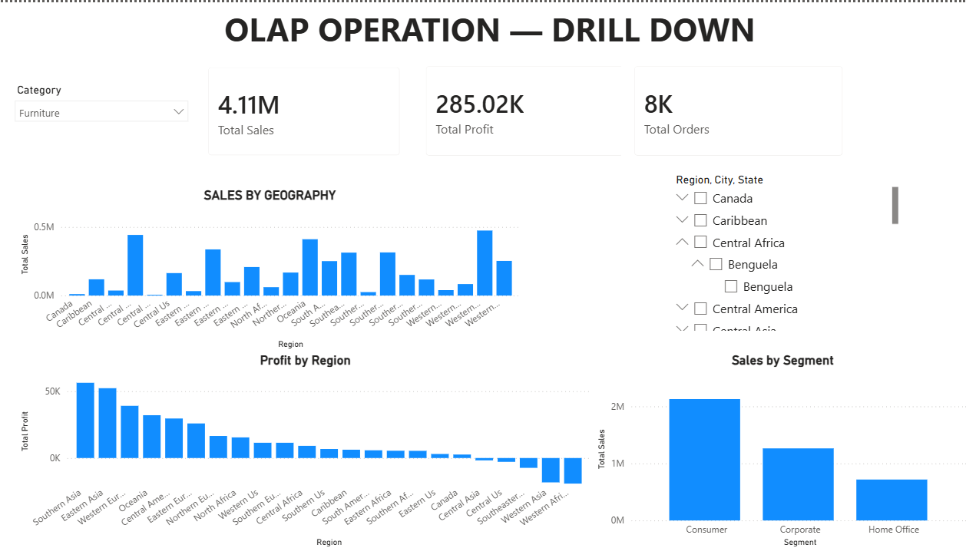 | 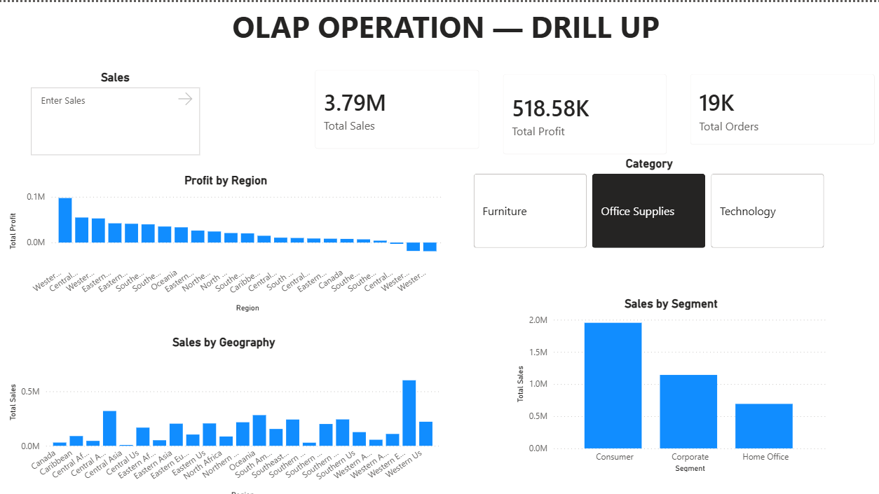

- Create a Comparative Analysis page with Sales by Category, Profit by Region, Top 10 Customers by Sales, and Sales Trend by Year charts.
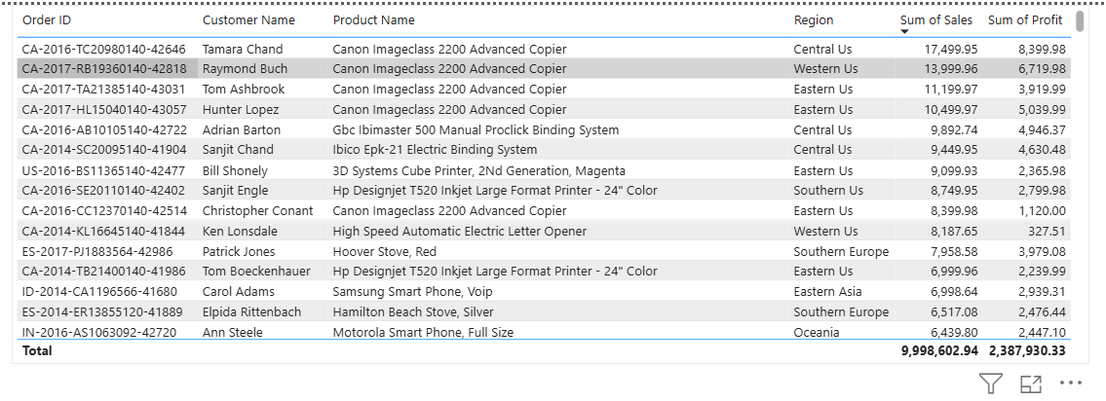
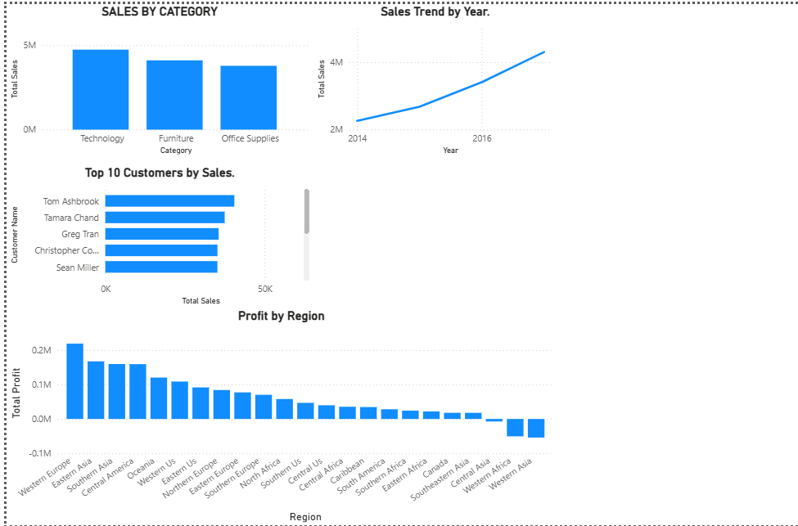

- Create a Dashboard page with KPI cards and three slicers for interactive analysis.
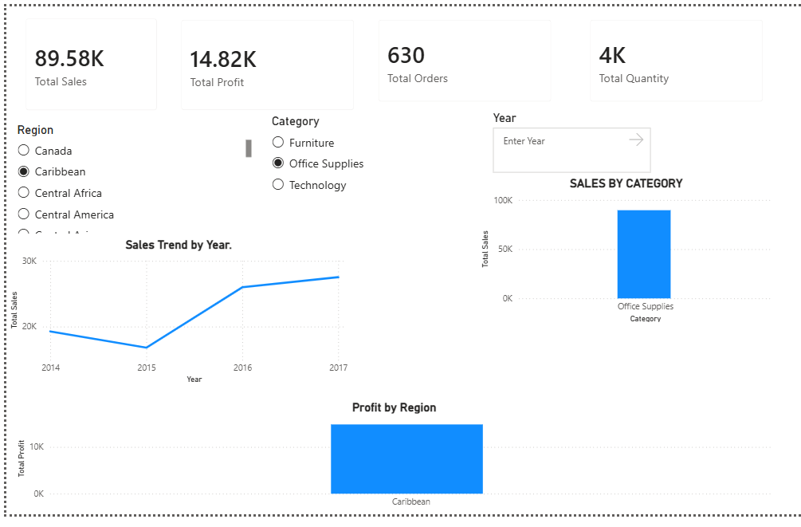

- Test slicers to verify that they filter all dashboard visuals correctly.

- Complete the observation table and interpret the reports for business decision-making

RESULT:
Relational and multidimensional reports were generated successfully using the existing star schema. Comparative charts and an interactive dashboard were created to support business analysis and decision-making.
LEARNING OUTCOMES:
- Generated relational reports using transactional data.
- Created multidimensional reports using Geo_Hierarchy.
- Applied sorting, filtering, and drill operations.
- Designed interactive dashboards using Power BI.
- Interpreted business insights through visualizations.

